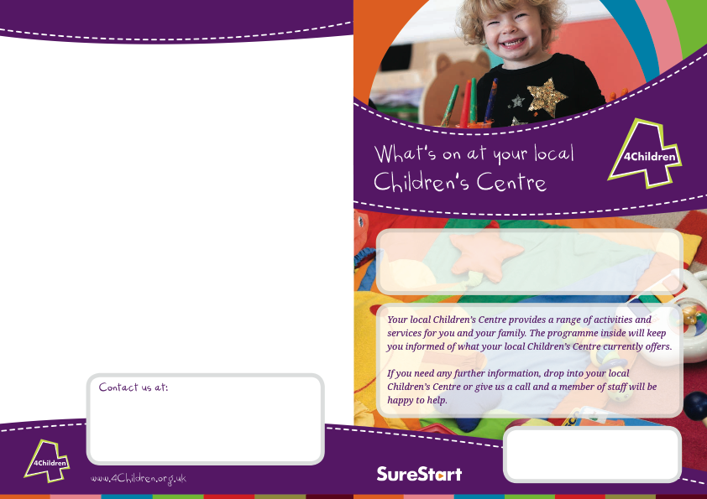

# We run groups and offer one to one sessions for families with children under five. If you would like to know more about any of the services on offer, please contact your local Children’s Centre.

## Windmill Children’s Centre

## Bursledon School Campus, Long Lane, Bursledon, SO31 8BZ.

## 023 80 405 189

### The West End Gateway, The Nest & Hop-A-Long Children’s Centres

### Main Office: Wildern Lane, Hedge End, SO30 4EJ

### 014 89 796 395

**Little Coppice Children’s Centre**

**Botley Road, Fair Oak, SO50 7AN**

**023 80 602 799**

# Other Venues:

Hop-A-Long Children’s Centre, Botley CofE Primary School, SO30 2EA.

West End Gateway, Townhill Farm Community Centre, SO18 3RA.

**Bishopstoke Evangelical Church**, Stoke Park Road, Bishopstoke, SO50 6DA.

**January to April 2015**

**www.4children.org.uk or find us on Facebook.**

**Eastleigh Southern Parishes**

Child Minders Support Group (PACEY) Third Monday every month 9:45 – 11:30am (LC)

Foster Carers Support Group 26/01/15, 23/02/15, 23/03/15, 27/04/15 10:00 – 11:30am (LC)

Baby Meet

Every Monday (Term Time) (Starting 19/01/15) 1:00 – 2:30pm (LC)

## German Speaking Group 26/01/15, 23/02/15, 23/03/15, 27/04/15 1:00 – 3:00pm (WS)

## Child Minders Support Group (PACEY) 05/02/15, 05/03/15 9:30 – 11:30am (WS)

## Autism Support Group 19/01/15, 23/02/15, 16/03/15, 20/04/15 10:00 – 11:45am (WS)

**Child Minders Support Group (PACEY)**

**Fourth Monday every month 10-11.30 (TH)**

### Boogie Mites 3-4yrs

### Starts 05/01/15 10:30 – 12:00pm (WEG)

# January – April 2015

### Hedge End (TN), West End (WEG) & Botley (TH)

Fair Oak (LC) and Bishopstoke (BS)

## Bursledon and Netley (WS)

Stepping Stones

(PND Support Group) 09/01/15, 30/01/15, 13/02/15, 06/03/15 & 27/03815 9:30 – 11:15 (LC)

Breastfeeding Babes (Breastfeeding Support Group) Every Friday 9:30 – 11:00am (LC)

TLC Support Group

Starting 06/02/15 TBC 1:30 – 3:00pm (LC)

### Triple P (Parenting) Starting 06/03/15 9:30 – 11:30am (TH) Referral Only.

## Banana Babies

## Every Friday Baby Yoga £4 a session 10.30 – 11.30am (WS)

**Money Advice Service & National Careers Service Appointments are available on request. Please contact your local children’s centre to arrange a 1:1 appointment.**

Play Together Bishopstoke

Every Thursday (Term Time) 9:30 – 11:15am (BS)

TLC Support Group

Every Thursday Starting 15th January

10-11.30am (TN)

Walking Zombies (Sleep advice) Second Thursday of every month. Appointment only, contact Rebecca Welton by email: rswelton@sky.com (LC)

## Baby Meet

## (6 Week Course) Starting TBC 1:00 – 2:30pm (WS)

**We are currently looking for people to join our partnership boards. If you would like a say in your local children’s centre services then please contact you local centre for an application.**

1st Time Mums (Invite by Health Visitor)

1:30 – 3:00pm (LC)

## Speak Easy (8 Week Course) Starting 14/01/15 Time TBC (WS)

## PFAW Play Together Every Wednesday (Term Time) 9:30 – 11:00am (WS)

### Play Together (0-5yrs) Every Wednesday

### 10-11.30

### (Term Time) Starting 14/01/15 (WEG)

**Volunteering opportunities are available at your local children’s centre. Please contact us for more information.**

No Labels, No limits

(Additional Needs Support Group) Jan TBC, 17/02/15, 17/03/15, 14/04/15 (LC)

HENRY (Healthy Eating) Starting 13/01/15 10:00 – 12:30pm. Referral Only (LC)

Triple P (Parenting) Starting 12/01/15 1:00 – 3:00pm (LC) Referral Only.

## Boogie Mites (6 Week Course) Starting 06/01/15 10:00 – 11:00am (WS)

## TLC/Young Parents

## Every Tuesday 1:00 – 2:30pm (WS)

## Baby Massage

## (5 Week Course) Starting 24/02/15 10:00 – 11:00am (WS)

### PEEP (Under 1’s) Starting 20/01/15 1:00 – 2:30pm (8 week course) Referral Only. (TN)

