4Children submission to the Localism Enquiry
4Children is delighted to have the opportunity to submit evidence to the Localism Inquiry.
4Children is a leading national charity which undertakes research, develops policy and delivers support for children and families. The organisation has a strong track record of successfully shaping and implementing public policy and led the call for a number of leading policy reforms and interventions including Sure Start Children’s Centres and the development of childcare and support for young people.
We are currently undertaking a major 18 month enquiry into the needs of families which will report in October this year. The Family Commission has spoken to thousands of families and will put forward far reaching recommendations on all aspects of family support. The organisation also has extensive experience in delivery, working on commission to central government and local authorities to deliver strategic support.
This submission draws on this experience to state that:
- 4Children believes in a community empowerment approach to localism with democratic controls

- We are committed to supporting a strong and vibrant role for local communities as shapers and leaders of local services and neighbourhoods and are actively engaged in developing and supporting families and communities to take on this role

- Our research shows that this is an approach which families and young people would support

- To achieve this requires a major change in the approach of central and local government including funding streams

- However communities will also need support to deliver this and there is a major community capacity building exercise which needs to be undertaken

- Without this local communities will not be able to take on a more active role and the exercise will simply revert to ‘outsourcing’. We believe that there is a much greater potential to deliver a more effective and accountable system which also builds the capacity and human capital within the community

- There are some key services such as Children’s Centres and Youth Provision which have the potential to be at the forefront of such a change
ABOUT 4CHILDREN

4Children is a leading national charity which undertakes research, develops policy and delivers support for children and families.

The organisation has a strong track record of successfully shaping and implementing public policy and led the call for a number of leading policy reforms and interventions including Sure Start Children’s Centres, the development of childcare and support for young people. We are currently undertaking a major 18 month enquiry into the needs of families which will report in October this year. The Family Commission has spoken to thousands of families and will put forward far reaching recommendations on all aspects of family support.

The organisation has extensive experience in delivery, working on commission to central government and local authorities to deliver strategic support. 4Children has worked with all local authorities to support the development of their services, including childcare, in and around schools and has been contracted by DfE to deliver support to all local authorities. The organisation has high level strategic relationships or partnerships with a significant number of these.

We also directly deliver a growing number of Children’s Centres, childcare, youth provision and broader family support.

This submission is drawn from our experience:

  - As advocates of support for children, young people and families
  - As architects of models and programmes of delivery
  - As supporters and developers of services such as Children’s Centres, youth provision and family support – advising and supporting local authorities and central Government
  - As deliverers of services including 25 Sure Start Children’s Centres

Our starting points
4Children understands that much of modern local government has grown from the municipal and co-operative movements in the mid to late 19th century. More recently, we believe that local government and to some extent the broader public sector have been confused with delivering local services rather than facilitating or being accountable for them.
4Children is drawn to a model of community empowerment with democratic controls, however, we do not believe that this has to be a contract management model reminiscent of Lord Tebbit’s view in the late 1980’s that local authorities should consist of a series of officers and members commissioning contracts. This, in our view, is not about localism but about a difference in operational management style. Our starting point is one of genuine engagement and empowerment of communities to lead and shape all aspects of the local neighbourhood.
We base this on a belief that:
- Communities have the capacity to do much more for themselves – in both shaping and delivering
- Communities are the solution not the problem
- Communities can deliver effective services at a lower price
- Communities can operate proper and appropriate governance arrangements to do so
Whilst we believe in a strong democratically accountable and local public sector, for us, it is more an accountable and facilitatory role.

10,000 families tell us they want a more localised, involved approach to decisions
Our research with families shows that there is a strong willingness from families to be involved in this way. Over the last 18months 4Children has heard from 10,000 families through its national inquiry into family life – the Family Commission. Families have told us:
- That Local authorities are seen as distant and not relevant
- That they do not believe that their views are reflected in decisions about their local neighbourhood
- That they have views about their locality and local services and want those to be reflected
- That they want to be able to shape and lead their own solutions
- That they need help and support to do this

Our modelling is based on a number of key principles:

- That services should be good value for money
- That they should be ‘fit for purpose’ to the current ‘more for less’ environment
- That they are based on clear evidence of what works
- That they deliver high quality, effective services

To achieve this we believe that funding will need to be flexible and transparent with accountability at all stages. All our experience suggests that funding streams should be simple with short chains of distribution. The more agencies and layers involved and more complicated the process the less likely the funding is to reach the frontline.
We are very aware of the need to reduce budgets both centrally and nationally but do not believe that this should automatically lead to a drastic fall in the level of services. We believe that there is an opportunity to reshape and reorder how services are delivered in a way that genuinely brings benefits to the communities they serve. However, action will need to be taken by local authorities now to enable this to happen. It imperative that local authorities and central government avoids a ‘slash and burn’ approach to services which would run the risk of undermining the infrastructure and service base which already exists. Strong strategic prioritisation will be essential however, with a real opportunity to involve individuals and communities in shaping decisions. It will also be important to leave in place a programme which has future benefits for example programmes of early intervention.
We believe that there is a broad scope for decentralisation which should embrace all public sector and government agencies with a default to exempt services. However, we do not believe that there is a need for structural change to local authorities rather assuming that operational change will be the driver. We have been encouraged by the merger of Local authority Senior Management Teams and back office functions in some areas and think that this is an area which is worthy of greater consideration by many authorities.
The role of the Local Authority will therefore be:-
    - Democratic accountability
    - Commissioning
    - Quality
    - Standards
    - Community development
    - Provider of last resort

The extent to which decentralisation leads to more effective public service delivery; and what the limits are or should be of localism
There is a general census that size leads to economy of scale. This is undeniable however, it does not necessarily mean that if services are to be decentralised that it would lead to increased costs. The cost associated with different models of service delivery are influenced as much by the model of delivery as they are by the size and scale of delivery.

There is a general principle that the chain of supply between funding and delivery should be relatively short. Generally speaking the length of the funding chain increases cost. Each level of intervention in the funding stream adds to it, its own bureaucracy and as a consequence its own cost. Conversely a short funding stream whereby the commissioner and the deliverer are closely linked tends to reduce bureaucracy, increase focus on outcomes and ensure “more for less”.

Taking this to its logical conclusion 4Children would argue that funding streams and the commissioners should be as close to the community as possible.

A further important principle about decentralisation is flexibility in terms of funding. Highly regimented, single strand funding regimes reduce flexibility, reduce creativity, and increase bureaucracy. A more localised approach has the potential to provide more flexibility in budgets, reducing waste as communities respond to their particular needs.
With this in mind therefore it would be essential that funding streams are simple – complicated submissions, complicated returns, and complicated criteria for outcomes increase cost and undoubtedly reduce the capacity or appetite for communities to do things for themselves.

This does not mean that there should not be accountability nor does it mean that there should not be a focus on auditable trail of outcomes, merely common sense and perhaps applying “the man on the Clapham omnibus” principle.

The closer that the deliverer is to the community will:-

- Increase accountability to the end user client
- Increase greater ownership of the end result
- Increase reduced cost
- Focus much more on outcomes

However there are some key limiting factors to decentralisation which will need to be overcome. In our experience these are:-

- The size of the operational activity – it will be different for different operations but clearly there is a cost implication/cost reduction related to size
- Capacity – limitation to the capacity or willingness of a community to take on board services “or do things for themselves” – however 4Children would argue that the local authority or indeed a facilitator such as the third sector should be used to build that capacity to avoid a postcode lottery

The Lessons for Decentralisation from Total Place, and the Potential to Build on the Work Done Under that Initiative, Particularly through Place-Based Budgeting

4Children has been impressed by the developments of Total Place and believes that there is much to build on in the development of place based budgets and services.

Total Place gave important recognition to how a range of inter-active and interwoven activities can come together to have a major impact. It also recognised that bringing together different funding streams increased flexibility and creativity as well as the concept of inter-agency collaboration and a one stop shop. The concept of place based budgeting recognises that resources are driven by community needs and if pooled and used flexibility have the capacity to exponentially achieve results.

This is an approach that 4Children is taking in its Children’s Centres with some success.

The Role of Local Government in a Decentralised Model of Local Public Service Delivery, and the Extent to which Localism can and should Extend to other Local Agents
To achieve our model of community empowerment, experience suggests that the role of local government should be:-

- The provision of democratic accountability to a range of activities carried out on behalf of the community
- A commissioner of services
- A facilitator in order to ensure that the community has the capacity to undertake services much more for itself (It may need to use facilitators in the third sector to deliver this and build the capacity in the community)
- The provider of last resort

The local authority would hold to account performance and quality across various communities to avoid a postcode lottery in terms of provision and quality. The local authority may also seek to either provide if there were economies of scale to do so or purchase from other providers central technical or non-community services such as the back office functions of finance and IT support; senior management team.

The above model implies that economics of scale would be applied to local authorities for non-community based services such as the provision of “pan London” back office facilities in respect of finance, IT support etc. These non-community services would be purchased and managed.

Each community/borough would continue to have its democratic independence but would buy in advice and support from a much larger merged operational unit. However, in relation to community services housing, children services, family services etc these would be devolved to the community in order to ensure the community provide services that it wants and needs and is in control of the cost. As a consequence, the community may itself seek to employ individuals to provide some of these services or seek volunteers or the third sector to provide these services on their behalf.

This model would mean that those services which affect the community are devolved to a local one stop shop, are owned locally, are provide in part by the community itself, through the third sector, through staff employed directly by the community or purchased from larger units where necessary.

All back office functions would be centralised to achieve economy of scale. The inter-face of the community and the back office function would be the democratic inter-face which would be represented by “the local council”.

It is important to stress that this is not a contracting model but a much more socially responsible and community empowering model.

The Action which will be necessary on the part of Whitehall Departments to achieve effective decentralised Public Service Delivery

To deliver the model in one sense Whitehall might need to do nothing; cost savings and best practice might lead local authorities to this conclusion themselves.

Whitehall does however need to consider the following to put the context in place:-
- Ensure that funding streams are flexible
- Reduce bureaucratic overlay and reporting
- Provide advice and support on best practice models
- Reduce barriers to unofficial mergers at an operational level between authorities
- Review TUPE requirements to ensure a low cost conceptual model does not merely transfer staff costs from one environment to another but allows a realistic discussion to take place
- Enable mixing and matching of funding streams from various departments DoH, DoE, Transport etc
- Be more outcome and community focused

The impact of decentralisation on the achievement of savings in the cost of local public services and the effective targeting of cuts to those services
Savings can only be achieved if activity is stopped or done differently. 4Children is not advocating that children services are reduced. But we are arguing that they should be delivered differently.

There is clear evidence of our view that funds do not always get to the frontline communities for which they are intended. Indeed, our evidence suggests that between 30% and 50% of funding for Children’s Centres does not get to the local community.

We believe that passing services to the community enables clear decisions to be made which will improve both their effectiveness and the cost effectiveness:-

- Services can be brought from the third sector – which cost less than local authority model
- Communities can undertake some of the services themselves and indeed the 4Children model encourages this achieving further cost savings
- Funding streams can be merged to achieve greater impact achieving even further cost savings

4Children Community Partnership model

4Children is developing an innovative model to build Community Partnerships to support a community based approach to delivering children’s services.

4Children is passionately committed to the goal of joined up, community based support for all children and young people 0 -1 9 and their families. We are actively engaged in developing this model in our local delivery and are working with a number of local authorities to develop this approach. As stated, 4Children believes that there are particular benefits and opportunities for Children’s Centres and wider services for children, young people and families to be reshaped in this way. We are in dialogue with the Department for Communities and Local Government and the DfE on these issues. An outline of our approach is attached.

4Children would be delighted to provide more information on any aspect of this submission.
4Children: October 2010
The 4Children Community Partnership Model

4Children is passionately committed to the goal of joined up, community based support for all children and young people 0 -1 9 and their families. We are actively engaged in developing this model in our local delivery and are working with a number of local authorities to develop this approach. As stated, 4Children believes that there are particular benefits and opportunities for Children’s Centres and wider services for children, young people and families to be reshaped in this way. We are in dialogue with the Department for Communities and Local Government and the DfE on these issues.

We believe that such an approach offers a genuine model for the delivery of a seamless 0-19 approach which is capable of:

- Supporting children, young people and families throughout childhood and through all important transitional stages.
- providing early intervention and preventative support for children and families
- providing intergenerational activities and support – reaching out to the broader extended family
- Providing intensive support for vulnerable families
- Responding to the needs of the local community
- Embracing family health including GPs

Our approach is similar to Total Place in that it recognizes that a number of factors influence the life chances of individuals and that services will be most effective is they are able to work together in a combined approach.

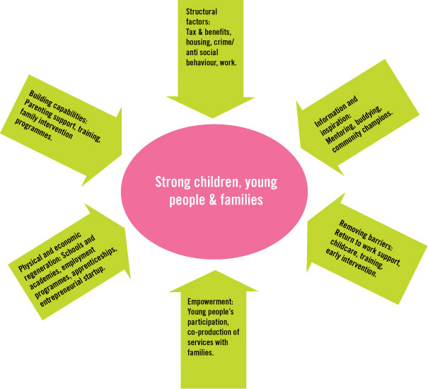

4Children’s community partnership model builds on this approach to integrate services in a locality around the needs of the local community.

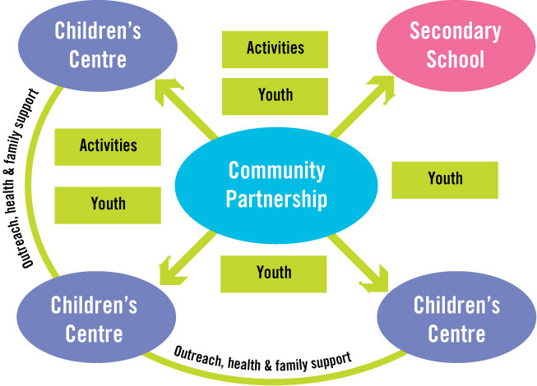

This approach is based on a definable geographic area – possibly around a secondary school.

Developing the community partnership model

The 4Children develops on an incremental basis to reach a broad range of services in a local area.

- Stage 1 – develop reach area of children centres to a broader cluster, probably based on a secondary school reach area
- Stage 2 – extend partnership to include wider services for schools age children and families
- Stage 3 – develop governance and management arrangements for extended services and children centres with the concept of the expansion to other integrated services
- Stage 4 – develop and expand youth services within the model
- Stage 5 – develop family social services (level 1 to 3)
- Stage 6 – develop family health services

This is supported by a phased approach from the local authority to build local ownership:

Phased steps to build local ownership:

Phase one – Dependency – May 2010
- Public spending
- High level planning and delivery
- Accountability to local authority

Phase two – Community capacity building
- Develop and disseminate the vision
- Develop community funding mechanisms
- Develop the entrepreneurial skills of service leaders
- Undertake community pilots
- Develop infrastructure and support from local authority – this means establishing a development and support team, capacity building training and quality development support
- Develop payment and funding structure to reflect a new enabling model

Phase three – Roll out - 2011
- Invest in new community funding
- Raise skill levels of those delivering to manage / take on
- Develop community capacity
- Create and embed approach/model within the community

Phase four – Sustainability
- Develop sustainable solutions model
- Support community ownership
- Establish new funding model
- Build community capital for sustainability

Phase five – Community doing it for themselves – 2012/13

