_{Co-operative Trust}

_{Factsheet Four}

The Brigshaw Cooperative Trust
Key Questions:
How would you sum up this approach?
What is a simple way of outlining its governance in a sentence or two?
How could this approach be applied to children’s centre and the voluntary and community sector (VCS) here?
What issues might arise about accountability?
From your perspective ( local authority, children’s centre and VCS including parents and community groups) how could this approach
- enable local VCS and parents groups become involved in delivering children centre services?
- help engage the VCS groups and families in reducing costs?
- help the VCS work with children’s centres improve outcomes and impact?
- improve your local arrangements?

Background
The Brigshaw Federation was created in the spring of 2008 following a period of increasingly close co‐operation between nine partner schools serving former coal‐mining communities in Outer East Leeds. The partnership was constituted through a ‘soft governance’ arrangement with a federated governing body overseeing specific joint activities but moved to a more formal arrangement in 2010.
Governance
Co-operative Trust model where staff, parents/carers, pupils and community representatives can become members of the Trust and can help shape the way the Trust works inspired by a clear vision of four core aims of education, aspiration, imagination and dedication. Key trust partners are
- The Leeds City College
- Leeds Children Services
- The Co-operative College and The Co-operative Group,
- Leeds Metropolitan University and CCDU
- CAPE UK ( independent research and development agency
An elected 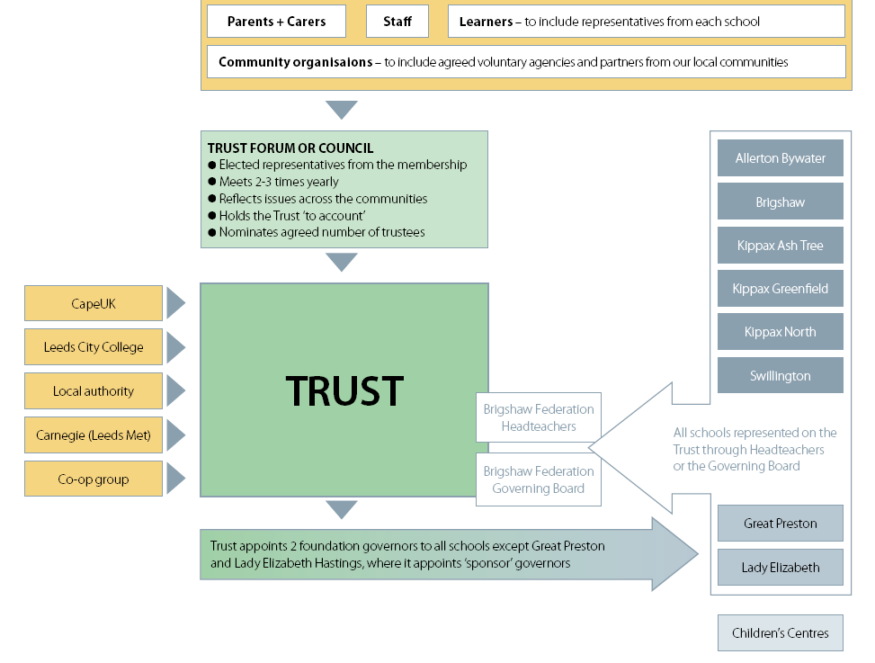Forum from the members scruntises the Trust, sets the strategy and holds capital assets but local Governing bodies are the employers. The schools remain within the Local Authority.

Accountability
- Clearly defined outcomes agreed by the Trust and the partners.
- Robust and transparent mechanisms for information about performance and financial management possible through its governance structures.
- They have development team and committee structure rather than a single lead but reporting lines do appear to go back to the schools and partners.
- Very clear governance arrangements drawing on cooperative expertise but potential for conflict between Trustees and Forum Members.
- School improvement, leadership capacity and workforce development along with cost savings are key goals but not clear how failure would be dealt with.
- Budgets appear to be that of individual schools with some delegated to support infrastructure but not immediately clear how funds linked to the Trusts outcomes.
VCS Engagement
VCS partners are directly engaged in the Forum council or as members
Pros Cons
Clear legal structure Complex to set up
Value driven Working relationships need to develop first
LA strategic oversight Education not children services key focus
VCS can have a clear role as a
consortia or partnership

For information on the current situation
http://www.brigshawfederation.com/

